CONTRACTIONS AND SIGNS OF LABOR

KEY POINTS
- Learning the signs of labor before your due date can help you feel ready for your baby’s birth.
- Signs of labor include strong and regular contractions, pain in your belly and lower back, a bloody mucus discharge and your water breaking.
- If you think you’re in labor, call your health care provider.
- Not all contractions mean you're in true labor. Learning the difference between true and false labor can help you know when it’s the real thing.

What is labor?
Labor (also called childbirth) is the process of your baby leaving the uterus (womb). You’re in labor when you have regular contractions that cause your cervix to change. Contractions are when the muscles of your uterus get tight and then relax. Contractions help push your baby out of your uterus. Your cervix is the opening to the uterus that sits at the top of the vagina. When labor starts, your cervix dilates (opens up).
As you get closer to your due date, learning the signs of labor can help you feel ready for labor and birth. If you have any signs of labor, call your health care provider.

What are the signs of labor?
You know you’re in true labor when:
- You have strong and regular contractions. A contraction is when the muscles of your uterus tighten up like a fist and then relax. Contractions help push your baby out. When you’re in true labor, your contractions last about 30 to 70 seconds and come about 5 to 10 minutes apart. They’re so strong that you can’t walk or talk during them. They get stronger and closer together over time.
- You feel pain in your belly and lower back. This pain doesn't go away when you move or change positions.
- You have a bloody (brownish or reddish) mucus discharge. This is called bloody show.
- Your water breaks. Your baby has been growing in amniotic fluid (the bag of waters) in your uterus. When the bag of waters breaks, you may feel a big rush of water. Or you may feel just a trickle.
​If you think you’re in labor, call your health care provider, no matter what time of day or night. Your provider can tell you if it’s time to head for the hospital. To see for sure that you’re in labor, your health care provider measures your cervix.

What are signs that you may be close to starting labor?
You may be close to starting labor if:
- Your baby drops or moves lower into your pelvis. This is called lightening. It means that your baby is getting ready to move into position for birth. It can happen a few weeks or even just a few hours before your labor begins.
- You have an increase in vaginal discharge that’s clear, pink or slightly bloody. This is called show or bloody show. It can happen a few days before labor starts or at the beginning of labor.
- At a prenatal checkup, your health care provider tells you that your cervix has begun to efface (thin) and dilate (open). Before labor, your cervix is about 3.5 to 4 centimeters long. When it’s fully dilated (open) for labor, it’s 10 centimeters. Once labor starts, contractions help open your cervix.
- You have the nesting instinct. This is when you want to get things organized in your home to get ready for your baby. You may want to do things like cook meals or get the baby’s clothes and room ready. Doing these things is fine as long as you’re careful not to overdo it. You need your energy for labor and birth.
If you have any of these signs, you may start labor soon. Learn the signs of labor so you know when to call your provider.

What are false labor and Braxton-Hicks contractions?
Not all contractions mean you’re in labor. You may have contractions on and off before true labor starts. These contractions are called false labor or Braxton-Hicks contractions. They soften and thin the cervix to help your body get ready for labor and birth. You may feel them in the weeks right before your due date. Learning the differences between true labor contractions and false labor contractions can help you know when you’re really in labor.
It can be hard to tell the difference between true labor and false labor. When you first feel contractions, time them. Write down how much time it takes from the start of one contraction to the start of the next. Make a note of how strong the contractions feel. Keep a record of your contractions for 1 hour. Walk or move around to see if the contractions stop when you change positions.
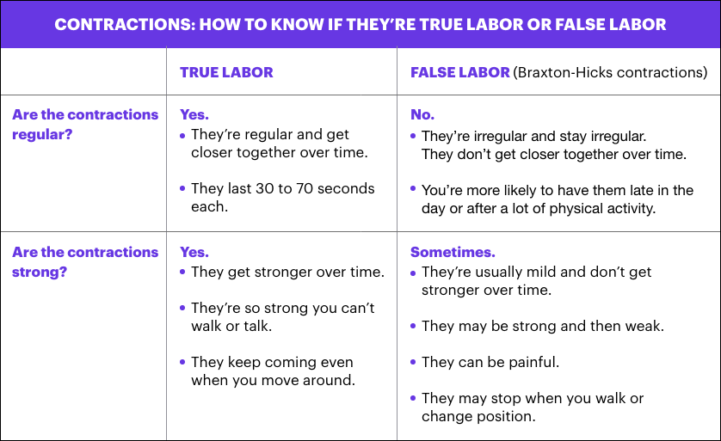

What is preterm labor?
Preterm labor is labor that begins too early, before 37 weeks of pregnancy. Premature babies (born before 37 weeks of pregnancy) can have health problems at birth and later in life. If you’re not to 37 weeks of pregnancy and you have signs or symptoms of preterm labor, call your provider. Getting help quickly is the best thing you can do. Learn about risk factors for preterm labor and what you can do to help reduce your risk.

What are stages of labor?
Stages of labor include the whole process of labor, from your first contractions (stage 1) to pushing (stage 2) to delivery of the placenta (stage 3) after your baby is born. Learning about the stages of labor can help you know what to expect during labor and birth.
Last reviewed: December, 2018

